Press Update




NEXUS Automotive International Awards Delphi Technologies Aftermarket as its Supplier of the Year 2022

- Global trading group NEXUS Automotive International has awarded Delphi Technologies Aftermarket Supplier of the Year during the latest edition of the NEXUS Business Forum in Vienna
- NEXUS shows appreciation of seven-year partnership with Delphi Technologies Aftermarket, which has seen successful global collaborations across all geographies and initiatives, such as investment in ‘Smart Mobility’
- Delphi Technologies Aftermarket and NEXUS continue their drive for a better and more sustainable Aftermarket during the on-going shift towards electrification, sustainability, and digitalization

WARWICK, UK – 09 MARCH 2022 - Delphi Technologies Aftermarket, a brand of BorgWarner Inc., has been awarded Supplier of the Year by NEXUS Automotive, the global automotive aftermarket, a testament to their successful collaboration and shared global vision for a better Aftermarket.
With the Supplier of the Year award, NEXUS recognizes the disruptive and innovative impacts of joint developments with Delphi Technologies, such as initiatives like investment in the Smart Mobility Venture Capital Fund Mobilion.
The award confirms the importance of the fast-growing partnership recognizing service excellence across all geographies and the importance of collaboration in the Aftermarket as the business shifts towards electrification and digitalization. Delphi Technologies and NEXUS are building on today’s business success by laying the foundations for more sustainable and accessible practices through new initiatives, and addressing the training and skill gap in the industry to prepare NEXUS members all over the world for the next-generation of vehicles coming into the aftermarket.
Neil Fryer, Vice President and General Manager Global Aftermarket comments: “We are truly honoured to be the recipients of this award. Great achievements come from the relationships we surround ourselves with, and our on-going partnership with NEXUS is a hallmark of collaborative success.”
He continues: “We share a bold vision for the Aftermarket, working to prepare for what is coming next. We are aligned with NEXUS in their ambition to make that journey more accessible to all markets, current and emerging, by creating a more connected and educated network through new initiatives and action.”
Gaël Escribe, NEXUS’ CEO added: “We are very proud to award Delphi Technologies Aftermarket with the title of Supplier of the Year, marking years of successful collaboration and many more to come, all the more that Nexus shares similar values with Delphi Technologies including innovation and agility.”
The award was presented at the NEXUS Business Forum 2022, in Vienna between 8th – 10th March.

About BorgWarner
BorgWarner Inc. (NYSE: BWA) is a global product leader delivering innovative and sustainable mobility solutions for the vehicle market. Building on its original equipment expertise, BorgWarner also brings market leading product and service solutions to the global aftermarket. With manufacturing and technical facilities in 93 locations in 22 countries, the company employs approximately 49,000 people worldwide. For more information, please visit borgwarner.com.

Delphi Technologies is a trademark of BorgWarner Inc. For more information, please visit delphiautoparts.com.

About NEXUS
Established in 2014, NEXUS is shaping the future of the automotive aftermarket. Thanks to an entrepreneurial global mindset, N! disrupts the automotive aftermarket bringing innovative solutions for a more sustainable, digital and connected mobility, while supporting its Community, wherever distributors and manufacturers are in the world, proving services to accelerate their growth.
N! is offering new approaches and new ideas for a connected, global and consolidated world of tomorrow to secure the success of car and heavy duty spare parts distributors and manufacturers by connecting and accelerating growth for both. More information: NEXUS Automotive international
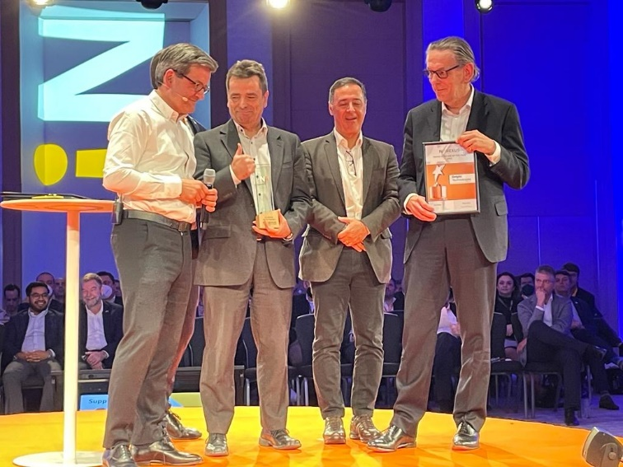

From Left: NEXUS! Automotive International CEO, Gaël Escribe; Delphi Technologies Aftermarket Vice President/GM Europe, Middle East & Africa, Jean-Francois Bouveyron; NEXUS! Automotive International Chairman, Gerson Prado; Delphi Technologies Global Aftermarket Vice President and General Manager, Neil Fryer; at NEXUS! Business Forum Awards Ceremony 2022

Download Image | Learn More

PR contact:
Sonia White
Phone: +34 696 260 719

Email: sowhite@borgwarner.com

NEXUS Press contact:
Julie Fontaine, Corporate Communication Manager at NEXUS
+ 33 6 26 73 39 03
Julie.fontaine@nexusautomotive.eu

